# Project 1 (Advanced)

## Using numpy and pandas to build trading algorithms (backtesting)

### Data Sources:

Gold prices: <https://datahub.io/core/gold-prices#data>

Stock prices (Ex. TCS): <https://finance.yahoo.com/quote/TCS.NS/history?p=TCS.NS>

### Steps to download stock prices:

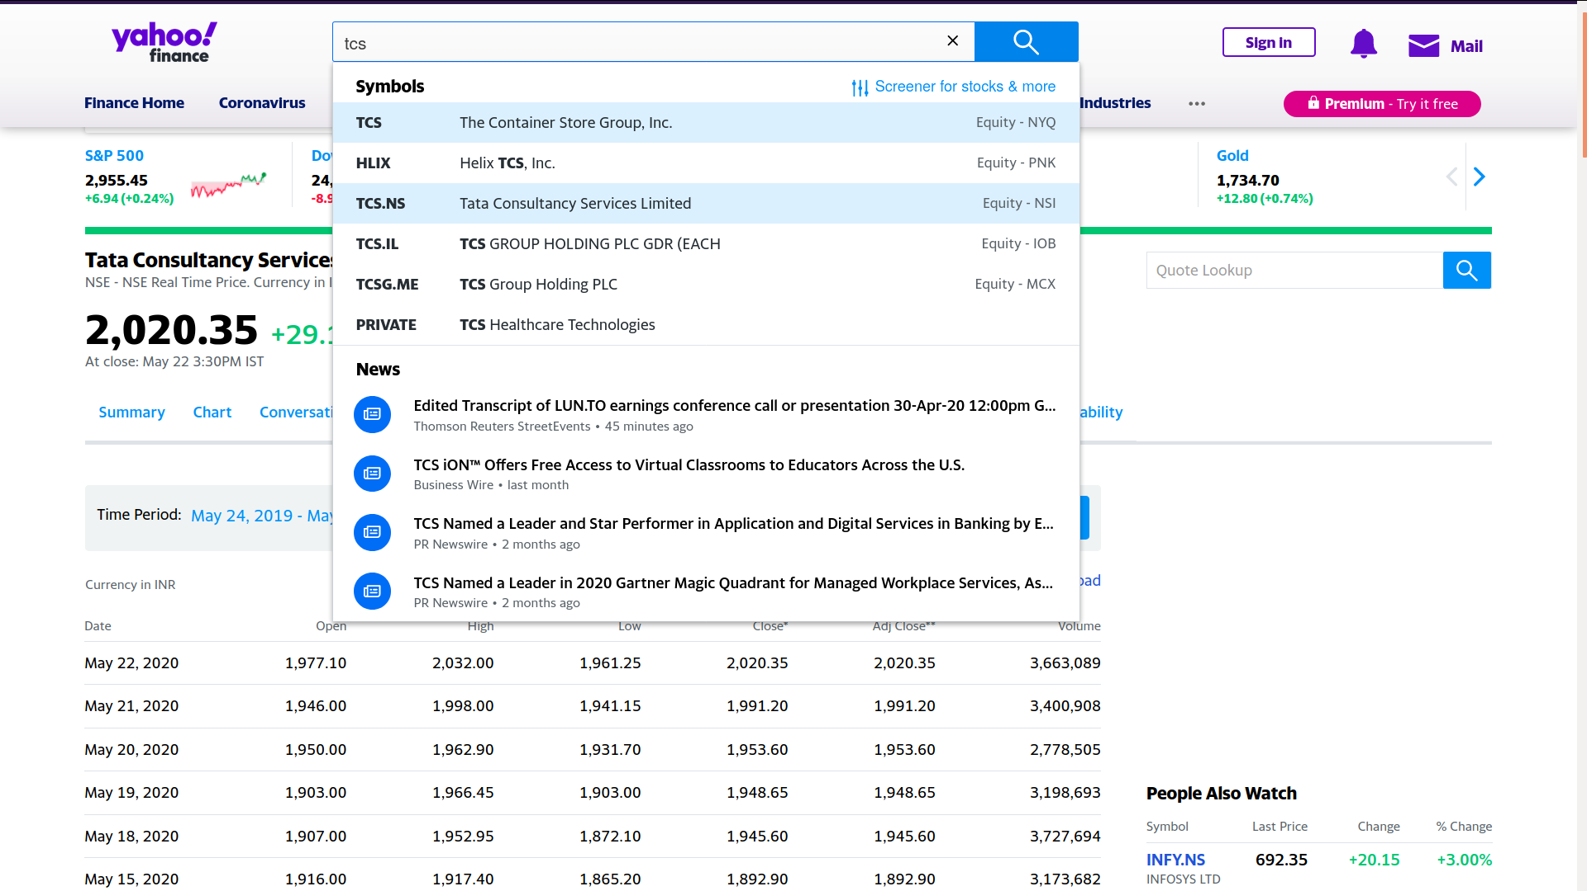**Step 1:** Search for a company

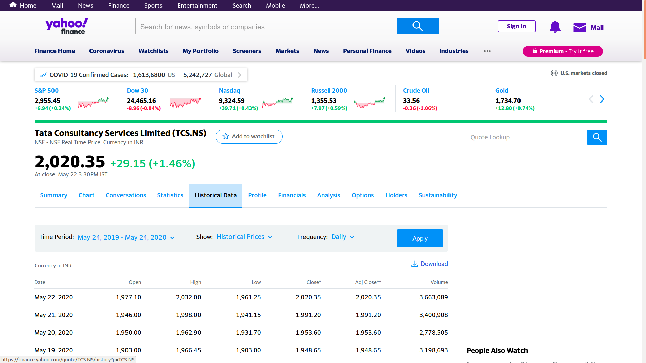**Step 2:**  Select “Historical Prices”

**Step 3:** Select the timeframe

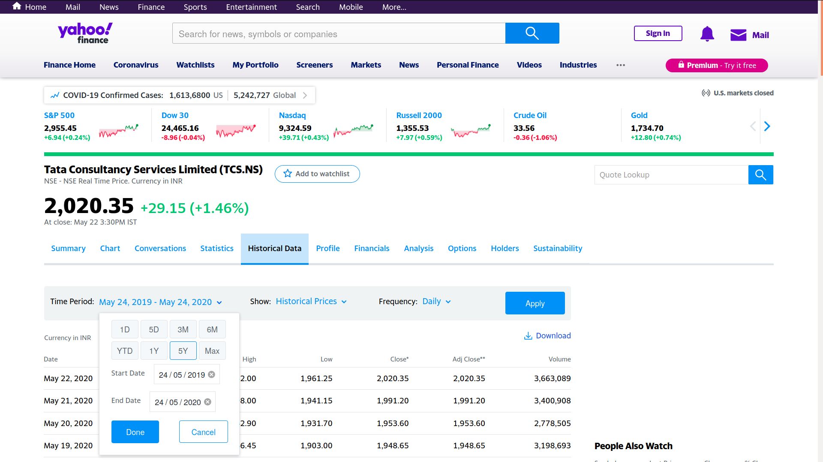

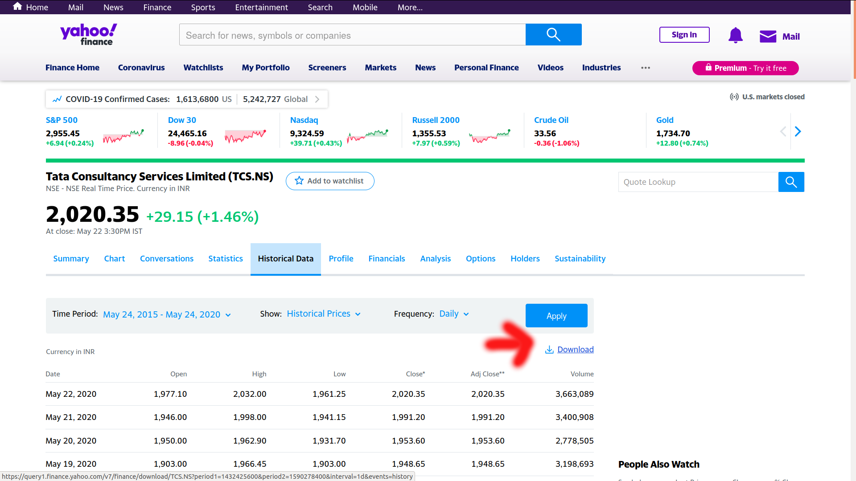**Step 4:** Click on apply and then click on download

### Understanding the downloaded dataset

Date: The day the data was collected

Volume: The number of stocks sold that day

Open: Stock price when the stock market opened

High: The highest price the stock was sold for that day

Low: The lowest price the stock was sold for that day

Close: The stock price when the stock market closed

### What you are expected to do:

Using the downloaded dataset, come up with algorithms that determine when to buy or sell a stock and calculate the profit/loss your trading algorithm achieves for the past year. Remember that you cannot use the high or low data for today while buying stock today as you will not know if the price might increase today or decrease. You can, however, use the high or low data from yesterday. At the end plot the profit or loss of your algorithm for a whole year.

### Some sample algorithms:

<https://www.pythonforfinance.net/2017/02/20/intraday-stock-mean-reversion-trading-backtest-in-python/>

<https://www.pythonforfinance.net/2017/07/31/bollinger-band-trading-strategy-backtest-in-python/>

## Some other advanced algos:

<https://www.pythonforfinance.net/category/trading-strategy-backtest/>